Operation Constraints

Ghulam Abbas: (FA20-BSE-053)

|  |  |
| --- | --- |
| **Operation constraints** | Take loan |
| **Operations** | saveLoanRequest (type, amount) |
| **Precondition** | Customer should have monthly income or he/she is financially able to pay the loan amount.  Signature of two witness is mandatory on the loan application form. |
| **Post condition** | Loan application is submitted successfully. Customer is informed about loan details. |

Use case 1: Take Loan.

|  |  |
| --- | --- |
| **Operation constraints** | Request loan |
| **Operations** | saveLoanRequest (type, amount) |
| **Precondition** | Customer should have monthly income or he/she is financially able to pay the loan amount.  Signature of two witness is mandatory on the loan application form. |
| **Post condition** | Loan application is submitted successfully. Customer is informed about loan details. |

Use case 2: Request For Loan.

Use case 3: Approve Loan.

|  |  |
| --- | --- |
| **Operation constraints** | Approve loan |
| **Operations** | CheckEligibility(income,ststus) |
| **Precondition** | Loan officer verify the customer income documentations and employment status. |
| **Post condition** | Loan application is approved successfully. Customer is informed about loan details.  Loan authorization approvals are recorded. |

SD Diagram

Ghulam Abbas: [FA20-BSE-053]

Use case 1: Take Loan

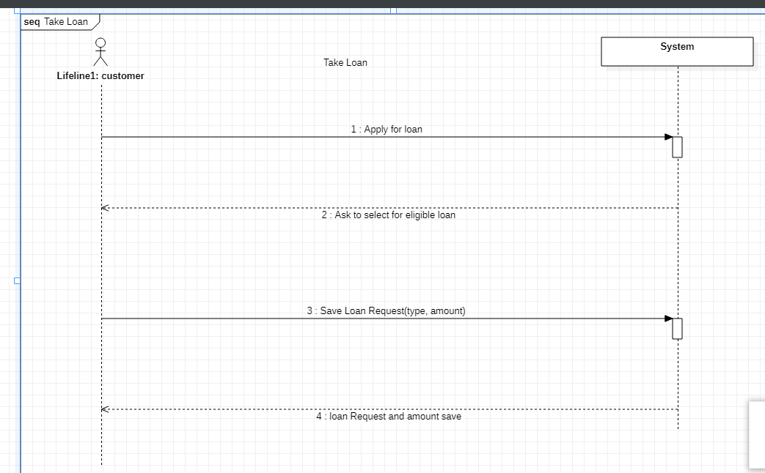

Use case 2: Request for Loan

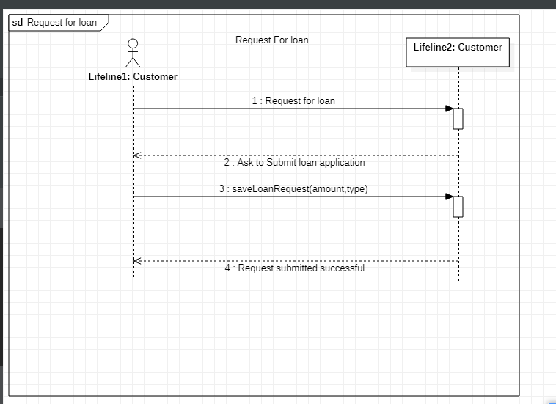

Use case 2: Approve Loan

